2.2.1 Data Extraction and Transportation Module

2.2.1.1 Data Extraction and Transportation with Sqoop Credit Card System Req-2.2.1 Data Extraction and Transportation with Sqoop

Functional Requirements

Utilize Sqoop to extract the following data according to the specifications found in the mapping document: 1. Branch data into CDW_SAPP_BRANCH 2. Credit Card Data into CDW_SAPP_CREDITCARD 3. Time data into CDW _SAPP_TIME 4. Customer Data into CDW _SAPP_CUSTOMER

Notes: • Data Engineers will be required to transform the data based on requirements found in the Mapping Document prior to loading the data into Hadoop.

• TIMEID is a field that the Data Engineers should create based on the DAY, MONTH, and TIME fields located in the CUSTOMER table. Format should be YYYYMMDD. For instance, January 4th, 2017 would become 20170104

• Data Engineers should extract the above data to the /Credit_Card_System/ folder in the Hadoop Filesystem

First step:use sqoop import data

1. very fast command: sqoop import every table into HDFS, create only one file.

sqoop import-all-tables --connect jdbc:mysql://localhost/CDW_SAPP --drive

r com.mysql.jdbc.Driver --warehouse-dir /user/maria_dev/Credit_card_System -m 1

2. sqoop import table into HDFS and participate it into 4 files.

sqoop import-all-tables --connect jdbc:mysql://localhost/CDW_SAPP --driver com.

mysql.jdbc.Driver --direct -m1

3.direct import into hive database

sqoop import-all-tables --connect jdbc:mysql://localhost/CDW_SAPP --driver com.

mysql.jdbc.Driver -m1 --hive-database Credit_card_System --hive-import

second step: create table time

1. METHOD: In MYSQL OR in hive, use followd command to create time table and insert data

create table CDW_SAPP_TIME(ID INteger, day varchar(2), month varchar(2), year varchar(4));

insert into CDW_SAPP_TIME(id,day,month,year) select concat(YEAR,lpad(MONTH,2,'0'),lpad(DAY,2,'0')) AS ID, DAY, MONTH, YEAR FROM CDW_SAPP_CREDITCARD;

1. Method: use sqoop import column data: day, month, year to hive, create new table
2. sqoop import --connect jdbc:mysql://localhost/CDW_SAPP --driver com.mysql.jdbc.Driver --query 'SELECT concat(YEAR,lpad(MONTH,2,0),lpad(DAY,2,0)) AS ID, DAY, MONTH,quarter(concat(year,lpad(
3. MONTH,2,0),lpad(day,2,0))) as QUARTER, YEAR FROM CDW_SAPP_CREDITCARD WHERE $CONDITIONS' --target-dir /user/maria_dev/CREDIT_CARD_SYSTEM --fields-terminated-by '\t' --split-by ID -m1 --hive-import --hive-table cr
4. edit_card_system.CDW_SAPP_TIME

3. Method: use sqoop query command import data TO HDFS

sqoop import --connect jdbc:mysql://localhost/CDW_SAPP --driver com.mysql.jdbc.Driver --query 'select concat(YEAR,lpad(MONTH,2,'0'),lpad(DAY,2,'0')) AS ID,DAY,MONTH,quarter(concat(YEAR,lpa

d(MONTH,2,0),lpad(DAY,2,0))) as QUARTER,YEAR from CDW_SAPP_CREDITCARD WHERE $CONDITIONS' --target-dir /user/maria_dev/CREDIT_CARD_SYSTEM --fields-terminated-by '\t' --split-by ID -m1

2.2.2 Data Loading with Hive

Credit Card System

Req-2.2.2

Data Loading with Hive

Functional Requirements Utilize Hive to create tables in the Hadoop Filesystem and then load the data extracted via Sqoop into those tables.

Data Engineers will be map to transform the data based on requirements found in the Mapping Document.

SELECT * from cdw_sapp_customer INTO OUTFILE 'C:/tmp/cdw_sapp_customer.csv'

FIELDS ENCLOSED BY '"' TERMINATED BY ';' ESCAPED BY '"'

LINES TERMINATED BY '\r\n';

Method 1: in linux command line:

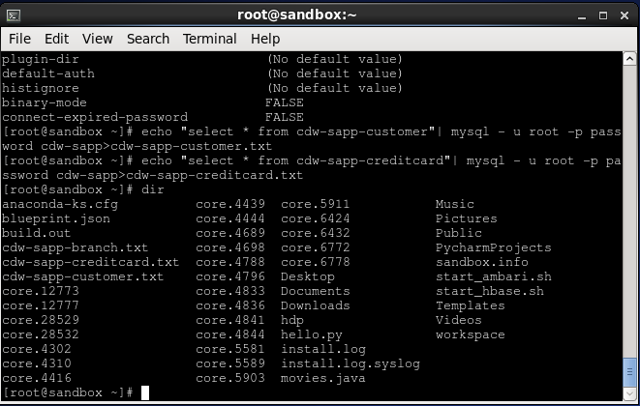

[maria_dev@sandbox ~]$ hadoop fs -put cdw_sapp_branch.txt /user/maria_dev/Credit_card_System/

[maria_dev@sandbox ~]$ hadoop fs -put cdw_sapp_customer.txt /user/maria_dev/Credit_card_System/

[maria_dev@sandbox ~]$ hadoop fs -put cdw_sapp_creditcard.txt /user/maria_dev/Credit_card_System/

[[maria_dev@sandbox ~]$ hive --hiveconf hive.root.logger=warn,console

Logging initialized using configuration in file:/etc/hive/2.5.0.0-1245/0/hive-log4j.properties

hive> use Credit_card_System;

OK

Time taken: 3.044 seconds

hive> show databases;

OK

credit_card_system

default

foodmart

movielens

xademo

Time taken: 0.381 seconds, Fetched: 5 row(s)

hive> show tables;

OK

branch

temp_branch

temp_creditcard

temp_customer

Time taken: 0.569 seconds, Fetched: 4 row(s)

hive> create table customer (firstname string, middlename string, lastname string, SSN string, credit_card_no string, APT_no string, street_name string, cust_city string, cust_state string, cust_country string,

cust_zip string, cust_phone string, cust_email string, last_updated string) row format delimited fields terminated by ',' stored as textfile Tblproperties("skip.header.line.count"="3");

OK

Time taken: 0.744 seconds

hive> LOAD DATA INPATH '/user/maria_dev/Credit_card_System/CDW_SAPP_CUSTOMER.csv' OVERWRITE INTO TABLE customer;

Loading data to table credit_card_system.customer

18/08/22 15:49:57 [main]: ERROR hdfs.KeyProviderCache: Could not find uri with key [dfs.encryption.key.provider.uri] to create a keyProvider !!

Table credit_card_system.customer stats: [numFiles=1, numRows=0, totalSize=162470, rawDataSize=0]

OK

Time taken: 2.104 seconds

Second Method: use Hadoop hive

use CDW_SAP

select * from CDW_SAPP_CUSTOMER;

ALTER TABLE CDW_SAPP_CUSTOMER ADD last_updated TIMESTAMP DEFAULT CURRENT_TIMESTAMP;

sqoop import --connect jdbc:mysql://localhost/CDW_SAPP --driver com.mysql.jdbc.Driver --table CDW_SAPP_CUSTOMER -m1 --target-dir /user/maria_dev/Credit_card_System/CDW_SAPP_CUSTOMER/ --inc

remental lastmodified --check-column last_updated --last-value 1 --append;

DROP TABLE CUSTOMER;

create table customer

( CUST_F_NAME VARCHAR(40), CUST_M_NAME VARCHAR(40), CUST_L_NAME VARCHAR(40),

CUST_SSN INT,CUST_CC_NO STRING,CUST_APT_NO STRING, CUSTO_STREET VARCHAR(38),

CUST_CITY VARCHAR(30), CUST_STATE VARCHAR(30), CUST_COUNTRY VARCHAR(30),

CUST_ZIP INT, CUST_PHONE VARCHAR(8), CUST_EMAIL VARCHAR(40), LAST_UPDATED TIMESTAMP )

row format delimited fields terminated by ','

STORED AS TEXTFILE

Tblproperties("skip.header.line.count"="3");

LOAD DATA INPATH '/user/maria_dev/Credit_card_System/CDW_SAPP_CUSTOMER/part-m-00000'

OVERWRITE INTO TABLE customer;

drop table CDW_SAPP_D_CUSTOMER;

create external table CDW_SAPP_D_CUSTOMER

( CUST_F_NAME VARCHAR(40), CUST_M_NAME VARCHAR(40), CUST_L_NAME VARCHAR(40),

CUST_SSN INT,CUST_CC_NO STRING, CUSTO_STREET VARCHAR(38), CUST_CITY VARCHAR(30),

CUST_COUNTRY VARCHAR(30), CUST_ZIP INT, CUST_PHONE VARCHAR(8),

CUST_EMAIL VARCHAR(40), LAST_UPDATED TIMESTAMP )

PARTITIONED BY (CUST_STATE VARCHAR(30))

row format delimited fields terminated by ','

LINES TERMINATED BY '\n'

location '/user/maria_dev/Credit_card_System/CDW_SAPP_CUSTOMER/';

SET hive.exec.dynamic.partition=true;

SET hive.exec.dynamic.partition.mode=nonstrict;

INSERT OVERWRITE TABLE CDW_SAPP_D_CUSTOMER

PARTITION (cust_state)

SELECT CONCAT(UCASE(SUBSTRING(cust_f_name, 1, 1)),LOWER(SUBSTRING(cust_f_name, 2))),

lcase(CUST_M_NAME),

CONCAT(UCASE(SUBSTRING(cust_l_name, 1, 1)),LOWER(SUBSTRING(cust_l_name, 2))),

cust_cc_no, concat(cust_apt_no," ",custo_street) as cust_street, cust_city,

cust_country,cust_zip, cust_ssn

concat(SUBSTRING(cust_phone, 1, 3),'-',SUBSTRING(cust_phone, 4, 4)),

cust_email, last_updated, cust_state

FROM CUSTOMER;

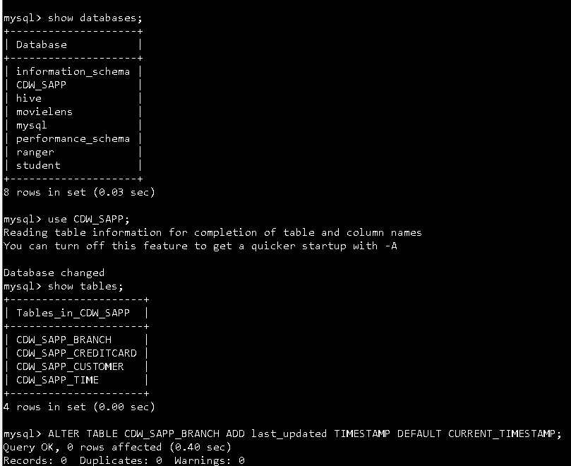

sqoop import --connect jdbc:mysql://localhost/CDW_SAPP --driver com.mysql.jdbc.Driver --table CDW_SAPP_BRANCH -m1 --target-dir /user/maria_dev/Credit_card_System/BRANCH;

drop table cdw_branch;

create table cdw_branch

( BRANCH_CODE INT,BRANCH_NAME VARCHAR(25), BRANCH_STREET VARCHAR(30),

BRANCH_CITY VARCHAR(30), BRANCH_STATE VARCHAR(30), BRANCH_ZIP INT,

BRANCH_PHONE VARCHAR(13), LAST_UPDATED TIMESTAMP )

row format delimited fields terminated by ','

STORED AS TEXTFILE

Tblproperties("skip.header.line.count"="3");

LOAD DATA INPATH '/user/maria_dev/Credit_card_System/BRANCH/part-m-00000'

OVERWRITE INTO TABLE cdw_branch;

drop table CDW_SAPP_D_BRANCH;

create external table CDW_SAPP_D_BRANCH

(BRANCH_CODE INT,BRANCH_NAME VARCHAR(25), BRANCH_STREET VARCHAR(30),

BRANCH_CITY VARCHAR(30), BRANCH_STATE VARCHAR(30), BRANCH_ZIP INT,

BRANCH_PHONE VARCHAR(13))

PARTITIONED BY (LAST_UPDATED TIMESTAMP)

row format delimited fields terminated by ','

LINES TERMINATED BY '\n'

location '/user/maria_dev/Credit_card_System/CDW_SAPP_BRANCH/';

SET hive.exec.dynamic.partition=true;

SET hive.exec.dynamic.partition.mode=nonstrict;

INSERT OVERWRITE TABLE CDW_SAPP_D_BRANCH

PARTITION(LAST_UPDATED)

SELECT BRANCH_CODE,BRANCH_NAME, BRANCH_STREET, BRANCH_CITY, BRANCH_STATE,

COALESCE(BRANCH_ZIP,99999),concat('(',substring(branch_phone,1,3),')',

substring(branch_phone,4,3),'-',substring(branch_phone,7,4)),

last_updated

FROM cdw_branch;

sqoop import --connect jdbc:mysql://localhost/CDW_SAPP --driver com.mysql.jdbc.Driver --query 'select concat(YE

AR,lpad(MONTH,2,'0'),lpad(DAY,2,'0')) AS ID,DAY,MONTH,quarter(concat(YEAR,lpad(MONTH,2,0),lpad(DAY,2,0))) as QUARTER,YEAR from CDW_SAP

P_CREDITCARD WHERE $CONDITIONS' --target-dir /user/maria_dev/Credit_card_System/time --fields-terminated-by '\t' --split-by ID -m1

drop table TIME;

create table TIME

( TIMEID VARCHAR(8), DAY INT, MONTH INT,

QUARTER VARCHAR(8), YEAR INT)

row format delimited fields terminated by '\t'

STORED AS TEXTFILE

Tblproperties("skip.header.line.count"="3");

LOAD DATA INPATH '/user/maria_dev/Credit_card_System/time'

OVERWRITE INTO TABLE TIME;

drop table CDW_SAPP_D_TIME;

create external table CDW_SAPP_D_TIME

( TIMEID VARCHAR(8), DAY INT, MONTH INT,

YEAR INT)

PARTITIONED BY (QUARTER VARCHAR(8))

row format delimited fields terminated by ','

LINES TERMINATED BY '\n'

location '/user/maria_dev/Credit_card_System/CDW_SAPP_D_TIME/';

SET hive.exec.dynamic.partition=true;

SET hive.exec.dynamic.partition.mode=nonstrict;

INSERT OVERWRITE TABLE CDW_SAPP_D_TIME

PARTITION (QUARTER)

SELECT TIMEID, DAY, MONTH,

YEAR, QUARTER

FROM TIME;

sqoop import --connect jdbc:mysql://localhost/CDW_SAPP --driver com.mysql.jdbc.Driver --query 'select TRANSACTI

ON_ID,CREDIT_CARD_NO, concat(YEAR,lpad(MONTH,2,'0'),lpad(DAY,2,'0')) AS TIMEID,CUST_SSN,BRANCH_CODE,TRANSACTION_TYPE,TRANSACTION_VALUE

FROM CDW_SAPP_CREDITCARD WHERE $CONDITIONS' --target-dir /user/maria_dev/Credit_card_System/CREDITCARD --fields-terminated-by '\t' --

split-by ID -m1;

drop table CREDITCARD;

create table creditcard

( TRANSACTION_ID INT, CUST_CC_NO STRING, TIMEID VARCHAR(8),

CUST_SSN INT,BRANCH_CODE INT, TRANSACTION_TYPE VARCHAR(30),

TRANSACTION_VALUE DECIMAL(20,3))

row format delimited fields terminated by '\t'

STORED AS TEXTFILE

Tblproperties("skip.header.line.count"="3");

LOAD DATA INPATH '/user/maria_dev/Credit_card_System/CREDITCARD'

OVERWRITE INTO TABLE creditcard;

drop table CDW_SAPP_F_CREDIT_CARD;

create external table CDW_SAPP_F_CREDIT_CARD

( TRANSACTION_ID INT, CUST_CC_NO STRING,CUST_SSN INT,

BRANCH_CODE INT,TRANSACTION_TYPE VARCHAR(30),

TRANSACTION_VALUE DECIMAL(20,3), TIMEID VARCHAR(8))

PARTITIONED BY (YEAR VARCHAR(4))

row format delimited fields terminated by ','

LINES TERMINATED BY '\n'

location '/user/maria_dev/Credit_card_System/CDW_SAPP_F_CREDIT_CARD/';

SET hive.exec.dynamic.partition=true;

SET hive.exec.dynamic.partition.mode=nonstrict;

INSERT OVERWRITE TABLE CDW_SAPP_F_CREDIT_CARD

PARTITION (YEAR)

SELECT TRANSACTION_ID, CUST_CC_NO, CUST_SSN,

BRANCH_CODE ,TRANSACTION_TYPE ,

TRANSACTION_VALUE , TIMEID,SUBSTRING(TIMEID,1,4) AS YEAR

FROM creditcard;